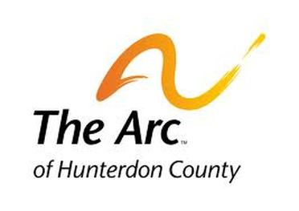
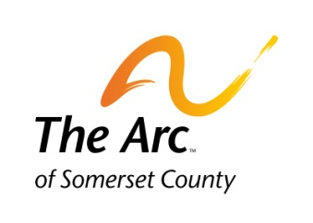
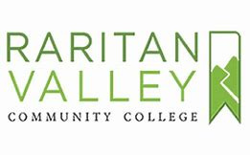
The Achievement Center at RVCC

THE FACTS

Academics

The Achievement Center at Raritan Valley Community College is a certificate-based, post-secondary program for students with intellectual and developmental disabilities interested in developing their education for continue to gain skills to enter the workforce.

The Achievement Center recognizes that every student learns and processes information differently. Through the use of student-centered curriculum and individualized strategies, the Achievement Center provides a bridge and support to help students achieve their individualized goals.

Our college-level classes and student-centered approach empowers our students to find the right learning tools for them. To meet their goals, the Achievement Center has created academically inclusive and specialized classes include instruction in:

- Reading Comprehension and Critical Thinking
- Writing and Research
- Public Speaking and College Presentations
- Employment and Career strategies
- Interpersonal Communication
- Social Skills Training
- Functional Mathematics
- College Planning and Strategies

Through these series of classes it offers our students an opportunity to “learn their voice” and acclimate themselves to the classroom and college experience. Each student learns differently and demonstrates their knowledge of class material in various ways. The Achievement Center helps students identify their study habits; note-taking skills; self advocacy in the classroom and on campus; and learn advantages to student planning and time management.

We challenge our students to critically examine reading material (short stories, poetry, novels); explore their writing abilities (Essays, Research papers); communication and social skills training; career development; and oral presentations. As a result, our students build confidence, empowerment, independence, and create new individual goals and aspirations.

Admission to The Achievement Center

The Achievement Center at Raritan Valley Community College is a certificate-based, post-secondary program (not an accredited college degree program) for students with intellectual and developmental disabilities. Our admission process includes a completed application; documentation of intellectual disability; in person interview; and latest copy of Individualized Education Program (IEP).

Instructions for Completing the Student Application

Applications are accepted online throughout the year. We are currently accepting applications for our Academic Year that starts in September (Fall/Spring Semesters 2020/2021).
- After your completed application has been submitted, you will receive written confirmation that it has been received. Applicants are contacted regarding their application and mandatory student/parent/family/guardian interviews are scheduled.

- Students wanted to be considered for this program must present documented disability that is characterized by significant limitation in intellectual functioning and in adaptive behavior.

- Due to space limitations, not all applicants who file an application and meet the criteria for admission will be accepted into The Achievement Center program.

- Students who are accepted to the program and meet academic requirements will receive a Certificate of Completion. Please note that acceptance are for a one year/2-semester period and are renewed annually as needed.

Cost:
- Classes offered by The Achievement Center are $1,050 per class, per semester
- Support options such as College Management are $1,050 per semester for times arranged by student and instructor.
- Additional offerings such as social groups, summer experiences and Club Friday Night Hangout are priced according to service and will have a published cost at the time of announcement.
- All students are to adhere to the Tuition policy in regard to payment and deadlines

At this time, the following Achievement Center courses are eligible for payment through NJ State Supports Program budgets under the service definition of Goods and Services:
- PAGE ONE: Thinking About Reading
- WRITING OUT LOUD
- COLLEGE SKILLS and STRATEGIES I & II
- CAREER DEVELOPMENT I and II
- EXPANDING COMMUNICATION and SOCIAL SKILLS for GROUPS
- STAGE FRIGHT: introduction to Public Speaking
- INDIVIDUAL COMMUNICATION
- MATHEMATICS and EVERYDAY LIFE
- RESEARCH and THE WRITING PROCESS
- CREATIVE WRITING I and II
- INDEPENDENT LIFE

All eligibility requirements and regulations for budgets apply as per The State of New Jersey.

Complete the application and submit it to:
Bob Hulit, Curriculum Coordinator
The Achievement Center at Raritan Valley Community College
Work Cell: 732-666-4781 Email: bobh@thearcofsomerset.org
Fax: 908-704-0850

